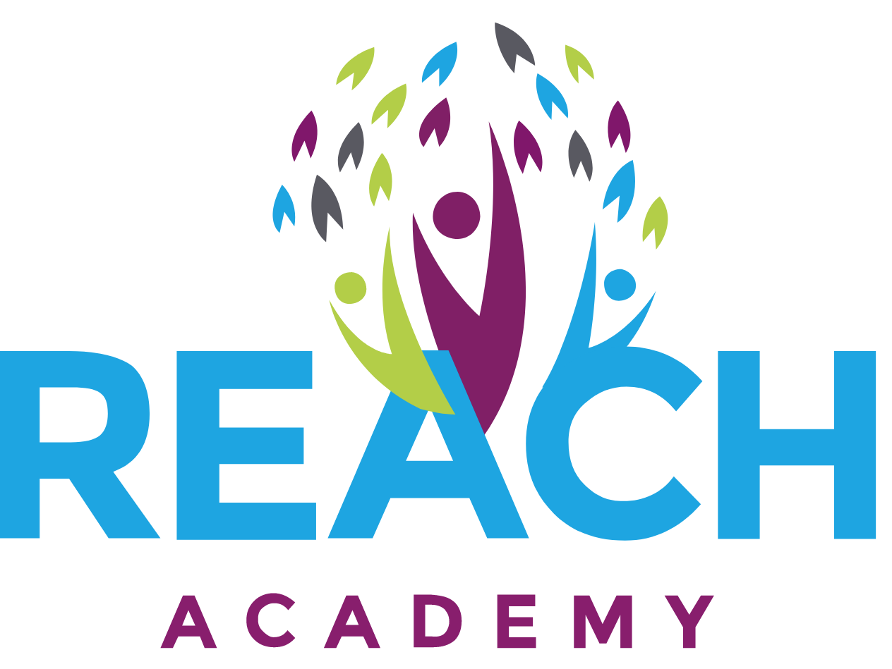

Relationships, Sex and Health Education (RSHE)

Relationships, Sex and Health Education (RSHE) Introduction
Ethos Academy Trust considers that Relationships, Sex and Health Education (RSHE) is an integral part of the Personal, Social, Health and Economic Education (PSHE) and is embedded throughout all the curriculum (e.g. science, PE, RE). We aim to offer students a carefully planned programme on human development, relationships, sexuality and family life within a safe, comfortable atmosphere and in a relaxed relationship between teacher and pupil. The programme is set within a moral framework and matched to the pupils’ level of maturity.
The attached guide created by the government outlines the requirements of schools and your rights to withdraw your child from some or all Sex Education lessons.

Parent consultation

 | Yes | No | Not sure | Feedback
1. Would you like support at home, on how to speak to your child about relationship and sex?

2. Has your child ever talked to you about something they learnt at school to do with growing up, sex or relationships?

3. Are there any changes or additions that you think should be made to the RSE Curriculum Outline?

4. Thinking about relationships and sex education, what do you believe is there a subject area that should be taught for different age groups/key stages and why?

5. Thinking about relationships and sex education, is there an area that you think should not be taught for different age groups/key stages and why?

Further comments

